Full Stack Design (FSD) Project Documentation: Book A Doctor

Parameter | Details
Date | 18 June 2026
Team ID
Project Name | Book A Doctor

____________________________________________________

1. Introduction

- Project Title: Book A Doctor (MERN Stack Medical Appointment Scheduler)
- Team Members & Roles:

____________________________________________________

2. Project Overview

Purpose of the System
The Book A Doctor platform addresses the scheduling and information gap in medical clinics. By providing a centralized website where patients can search for approved doctors, book availability slots, and upload medical reports, the application digitizes the traditional waiting room and medical ledger workflows.

Key Features
- Role-Based Workflows: Tailored user dashboards for Patients, Doctors, and Administrators.
- Admin Verification: Registered doctor profiles are hidden until approved by an administrator.
- Real-time Slot Scheduling: Doctors can dynamically post consultation times, and patients can book specific slot times.
- Medical Records Storage: Patients can upload and manage prescriptions and laboratory results, serving files statically via the node server.
- Notification Feed: Users receive notification summaries in the page header when appointments are approved, rejected, or completed.

____________________________________________________

3. Architecture

The platform follows a classic MERN (MongoDB, Express, React, Node.js) architecture:

Frontend Architecture
- Built on React (using Vite as compiler and bundler).
- React Router manages client-side page routing.
- Context API (AuthContext) stores active login tokens, current user objects, and notifies components of logout actions.
- Styling implemented via clean, premium CSS selectors with responsive layouts.

Backend Architecture
- Built on Node.js running an Express.js API server.
- Handles endpoints routing, input parsing, file uploads handling via Multer, and error handler interception.
- Restricts actions using custom middlewares: protect (for JWT authorization) and authorize (for role restriction).

MongoDB Database Architecture
- Hosted on MongoDB, communicating via Mongoose ODM.
- Consists of four collections with referenced relationships:
- User: Base identity schemas (Patient, Doctor, Admin).
- Doctor: Extends User with specialized skills, pricing, and calendar slot availability arrays.
- Appointment: Connects Patients and Doctors to a scheduled slot with status flags.
- Document: Links file upload paths to specific Patients.

____________________________________________________

4. Setup Instructions

Prerequisites
- Node.js (v18.x or higher recommended)
- npm (v9.x or higher)
- MongoDB (Local Community Edition running on port 27017 or a MongoDB Atlas cloud URI)

Installation Guide
- Clone the Repository:
git clone <repository_url>
cd "Book A Doctor"

- Install Dependencies:
Install client and server packages simultaneously from the monorepo root:
npm run install-all

- Configure Environment Variables:
Create a .env file under the /server directory with the following contents:
PORT=5000
MONGO_URI=mongodb://localhost:27017/book-a-doctor
JWT_SECRET=bookadoctorsupersecretkey12345
JWT_EXPIRE=30d

Default Seeding Accounts
At database startup, a seeding utility runs to insert initial default accounts if the database is clean:
- Admin: admin@doctor.in / adminpassword
- Approved Doctor: sunita@doctor.in / doctorpassword
- Pending Doctor: rajesh@doctor.in / doctorpassword
- Patient: aarav@patient.in / patientpassword

____________________________________________________

5. Folder Structure

The repository is structured as a monorepo splits client and server concerns:

"Book A Doctor"/
├── client/ # React Frontend Single Page Application
│ ├── public/ # Static public assets
│ ├── src/
│ │ ├── assets/ # App logos and design components
│ │ ├── components/ # Reusable UI components (Navbar, ProtectedRoute, Sidebar)
│ │ ├── context/ # React Context objects (AuthContext)
│ │ ├── pages/ # Layout Pages (Home, Login, Register, Dashboards)
│ │ ├── services/ # API integration layers
│ │ ├── App.css # Main App layouts styling
│ │ ├── App.jsx # App routes config
│ │ └── main.jsx # App entry mounting point
│ ├── package.json
│ └── vite.config.js
│
├── server/ # Express Backend REST API
│ ├── config/ # Database connection and DB seeder files
│ ├── controllers/ # Route controllers matching API logic
│ ├── middleware/ # Security guards and file parsers
│ ├── models/ # Mongoose schemas definition
│ ├── routes/ # REST Express router maps
│ ├── uploads/ # Medical file uploads write repository (ignored in git)
│ ├── utils/ # Token generation files
│ ├── package.json
│ └── server.js # Server application configuration

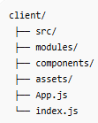
Client Folder Structure

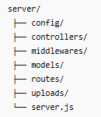
Server Folder Structure

____________________________________________________

6. Running the Application

Running Locally (Development Mode)
To launch both client and server development engines:

- Start Server:
cd server
npm run dev
# Runs on http://localhost:5000

- Start Client:
cd client
npm run dev
# Runs on http://localhost:5173

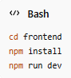
Running Client/Server

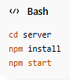
Database Connection

Building for Production
To build the client SPA and start the static Node delivery server:
npm run build
npm start

____________________________________________________

7. API Documentation

7.1 Authentication Routes (/api/auth)

1. Register User
- HTTP Method: POST
- Path: /api/auth/register
- Role Authorized: Public (Patient/Doctor)
- Request Body:
{
"name": "Dr. Amit Patel",
"email": "amit@doctor.in",
"password": "doctorpassword",
"role": "Doctor",
"phoneNumber": "+91-9988776655",
"address": "Delhi Medical Clinic",
"specialization": "Dermatology",
"experience": 10,
"fees": 600,
"about": "Dermatologist with 10 years experience.",
"location": "Vasant Kunj, Delhi"
}

- Response (201 Created):
{
"success": true,
"token": "eyJhbGciOiJIUzI1NiIsInR5cCI6IkpXVCJ9..."
}

2. Login User
- HTTP Method: POST
- Path: /api/auth/login
- Role Authorized: Public
- Request Body:
{
"email": "aarav@patient.in",
"password": "patientpassword"
}

- Response (200 OK):
{
"success": true,
"token": "eyJhbGciOiJIUzI1NiIsInR5cCI6IkpXVCJ9..."
}

3. Get Current User Details
- HTTP Method: GET
- Path: /api/auth/me
- Role Authorized: Protected (Patient/Doctor/Admin)
- Response (200 OK):
{
"success": true,
"data": {
"_id": "603d2b2f56b2cf00155b5f5a",
"name": "Aarav Mehta",
"email": "aarav@patient.in",
"role": "Patient",
"notifications": []
}
}

____________________________________________________

7.2 Doctor Routes (/api/doctors)

1. List Approved Doctors
- HTTP Method: GET
- Path: /api/doctors
- Role Authorized: Public
- Response (200 OK):
{
"success": true,
"count": 1,
"data": [
{
"_id": "603d2b2f56b2cf00155b5f5b",
"specialization": "Cardiology",
"experience": 15,
"fees": 800,
"location": "Fortis Hospital, Sector 62, Noida",
"isApproved": true,
"user": {
"name": "Dr. Sunita Sharma",
"email": "sunita@doctor.in"
}
}
]
}

2. Update Availability Slots
- HTTP Method: PUT
- Path: /api/doctors/availability
- Role Authorized: Protected (Doctor)
- Request Body:
{
"availability": [
{
"date": "2026-06-25",
"slots": ["09:00 AM", "10:00 AM", "11:00 AM"]
}
]
}

- Response (200 OK):
{
"success": true,
"data": {
"_id": "603d2b2f56b2cf00155b5f5c",
"availability": [
{
"date": "2026-06-25",
"slots": ["09:00 AM", "10:00 AM", "11:00 AM"]
}
]
}
}

____________________________________________________

7.3 Appointment Routes (/api/appointments)

1. Book Appointment
- HTTP Method: POST
- Path: /api/appointments
- Role Authorized: Protected (Patient)
- Request Body:
{
"doctor": "603d2b2f56b2cf00155b5f5c",
"date": "2026-06-25",
"timeSlot": "10:00 AM",
"reason": "Routine cardiac checkup"
}

- Response (201 Created):
{
"success": true,
"data": {
"patient": "603d2b2f56b2cf00155b5f5a",
"doctor": "603d2b2f56b2cf00155b5f5c",
"date": "2026-06-25",
"timeSlot": "10:00 AM",
"status": "Pending",
"reason": "Routine cardiac checkup"
}
}

2. Update Appointment Status
- HTTP Method: PUT
- Path: /api/appointments/:id/status
- Role Authorized: Protected (Doctor/Admin)
- Request Body:
{
"status": "Approved",
"notes": "Please bring previous reports."
}

- Response (200 OK):
{
"success": true,
"data": {
"_id": "603d2b2f56b2cf00155b5f5d",
"status": "Approved",
"notes": "Please bring previous reports."
}
}

____________________________________________________

7.4 Document Routes (/api/documents)

1. Upload Document
- HTTP Method: POST
- Path: /api/documents
- Headers: Content-Type: multipart/form-data
- Role Authorized: Protected (Patient)
- Request Body: Multipart form data with fields title (string) and document (file attachment).
- Response (201 Created):
{
"success": true,
"data": {
"patient": "603d2b2f56b2cf00155b5f5a",
"title": "Blood Report",
"fileName": "document-162391032321.pdf",
"filePath": "uploads/document-162391032321.pdf"
}
}

____________________________________________________

7.5 Admin Routes (/api/admin)

1. Get Administrative Statistics
- HTTP Method: GET
- Path: /api/admin/stats
- Role Authorized: Protected (Admin)
- Response (200 OK):
{
"success": true,
"data": {
"users": 10,
"doctors": 4,
"appointments": 12
}
}

2. Approve Doctor Account
- HTTP Method: PUT
- Path: /api/admin/approve-doctor/:id
- Role Authorized: Protected (Admin)
- Response (200 OK):
{
"success": true,
"message": "Doctor approved successfully"
}

____________________________________________________

8. Authentication & Authorization

- Backend Layer:
- JWT Token: Handled by custom helper generateToken(userId) creating a signature using the secret key with an expiration window of 30 days.
- Middlewares:
- auth.js intercepts incoming request header Authorization: Bearer <token>, decodes it, and attaches the active MongoDB user model to req.user.
- authorize('Admin', 'Doctor') verifies that req.user.role is listed in the route parameters before releasing access.
- Frontend Layer:
- AuthContext: Manages login/logout states, headers attachment, and saves user session payloads in local browser memory.
- ProtectedRoute.jsx blocks page rendering to patients attempting doctor or admin dashboard access and redirects unauthorized users to /login.

____________________________________________________

9. User Interface

The layout features dynamic screens that alter headers depending on the user's role:
- Home: Search specialist search bar and promotional services panels.
- Login/Register: Forms validating password sizes with instant role toggle fields.
- Doctors Listing: Filter list by cardiology, pediatrics, dermatology, etc.
- Doctor Details: Interactive scheduling grid, location cards, clinic fees, and consultation duration cards.
- Patient Dashboard: Medical files upload form, current bookings statuses grid, and notifications count list.
- Doctor Dashboard: Calendar slot addition form and pending/approved patient list.
- Admin Dashboard: Verification panels for doctor accounts, users manager lists, and counts blocks.

____________________________________________________

10. Testing

Strategy
- Unit Testing: Route controller modules are decoupled, allowing unit validation checks on database saves and password hashing.
- Integration Testing: Postman testing catalogs verified token validation rules and correct status code updates (400, 401, 403, 404, 500).
- User Acceptance (UAT): End-to-end testing scenarios validated via user UI clicks.

____________________________________________________

11. Screenshots & Demos

Home Page
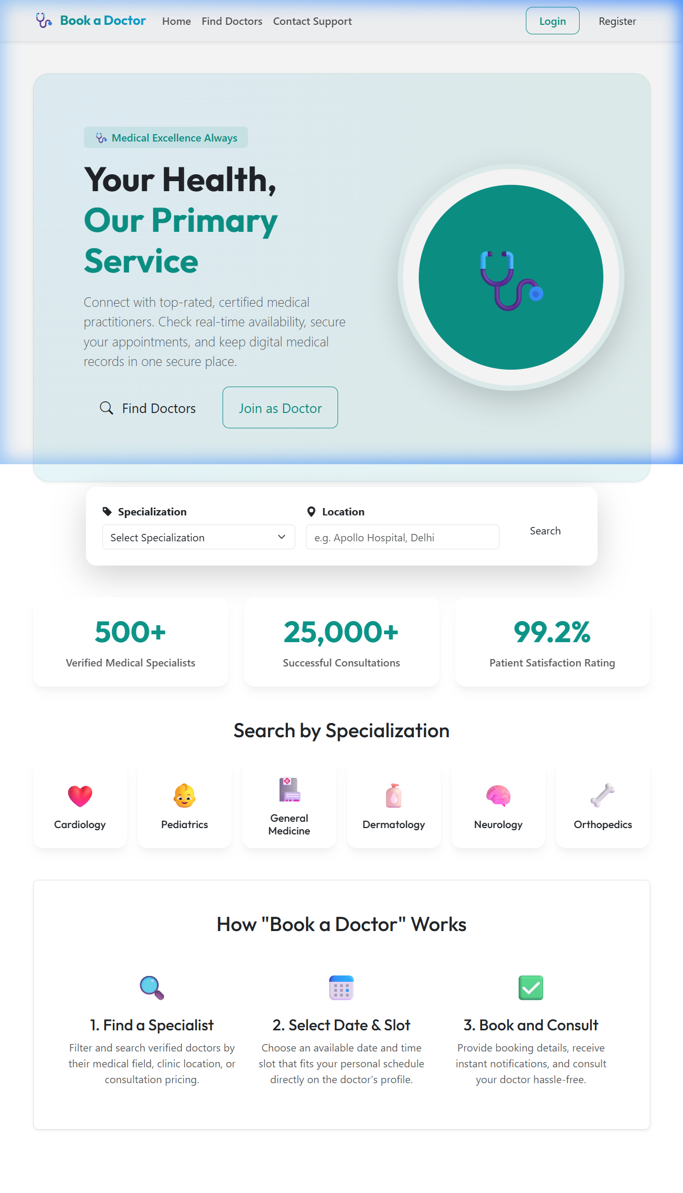
Home Page Screenshot

Register Page
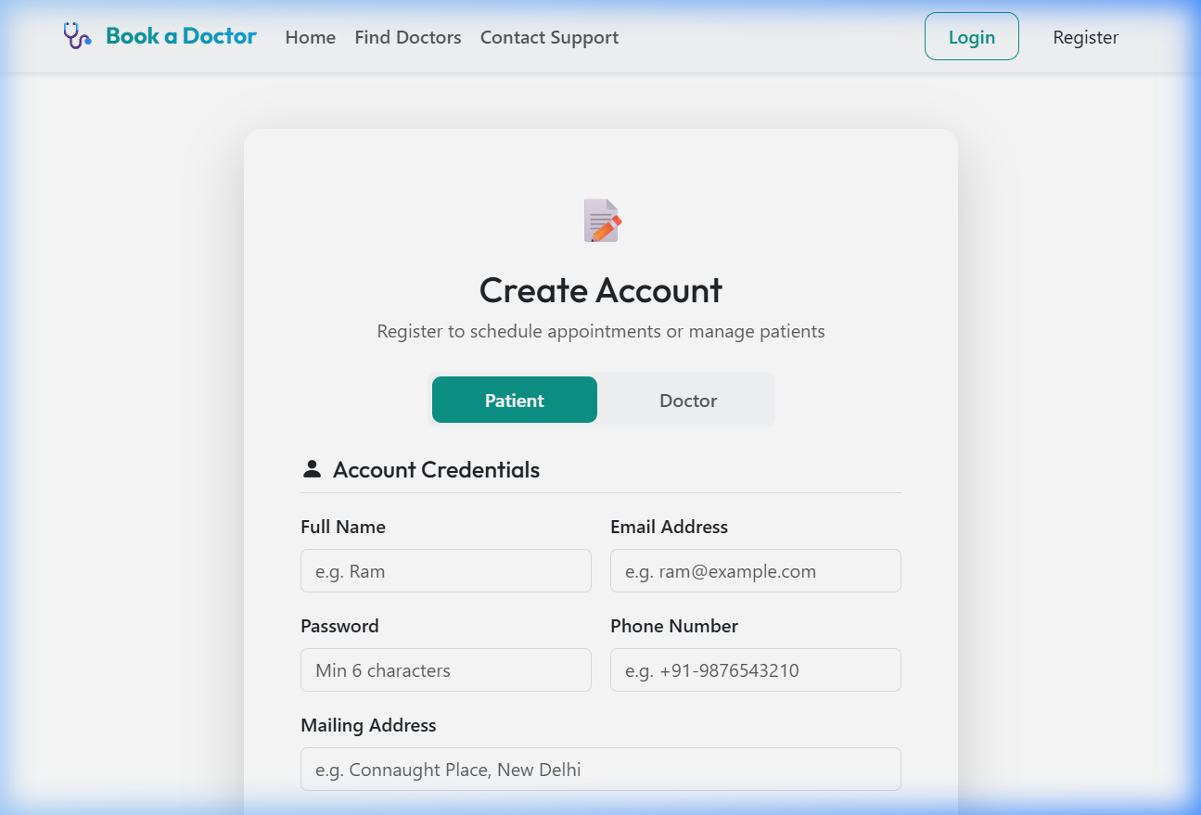
Register Screen

Login Page
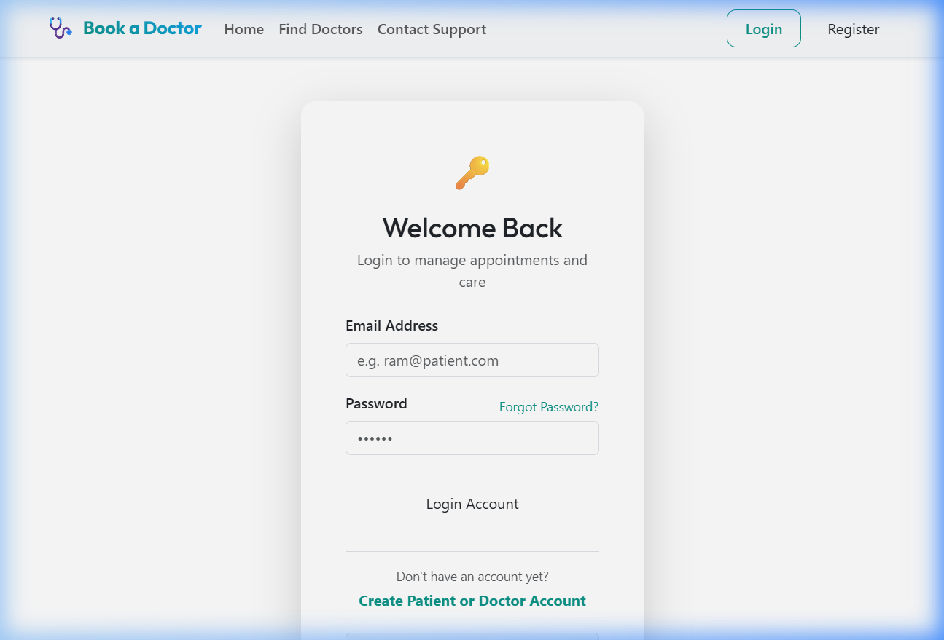
Login Screen

Patient Dashboard Page
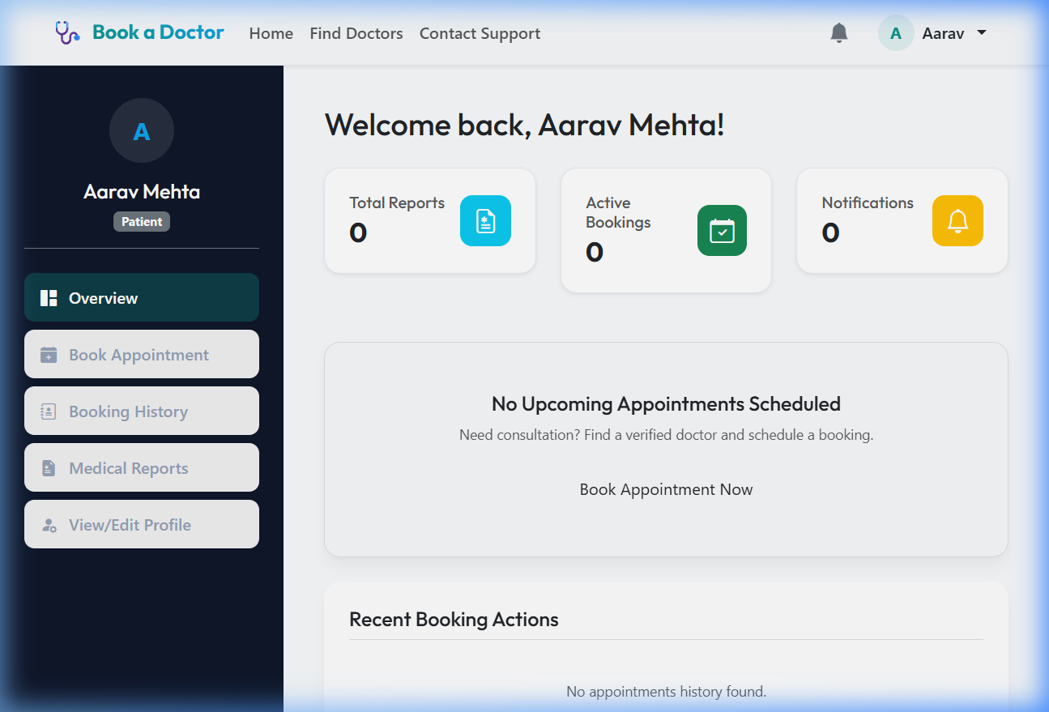
Dashboard Screen

Doctors Listing
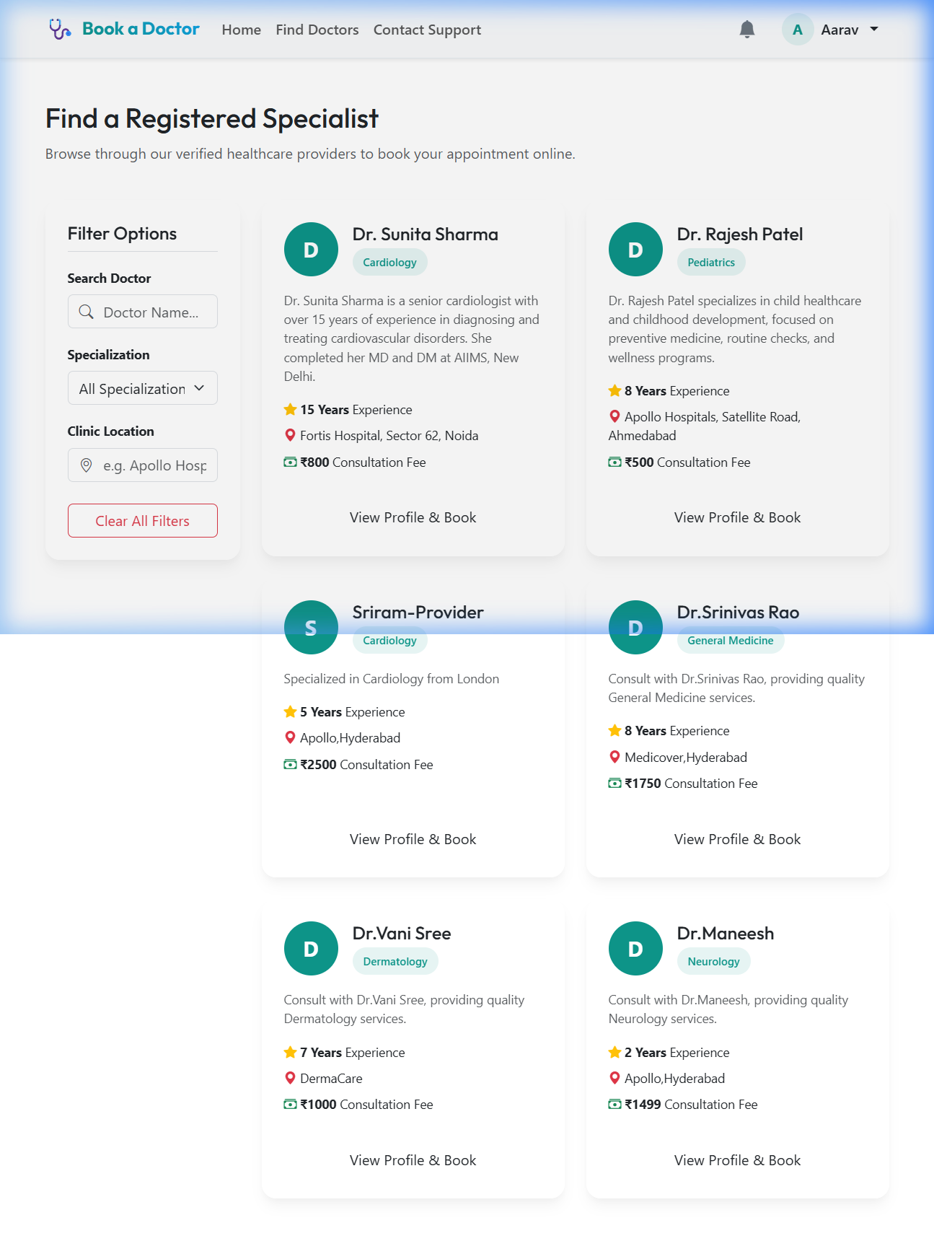
Doctors Listing Screen

Doctor Details & Calendar
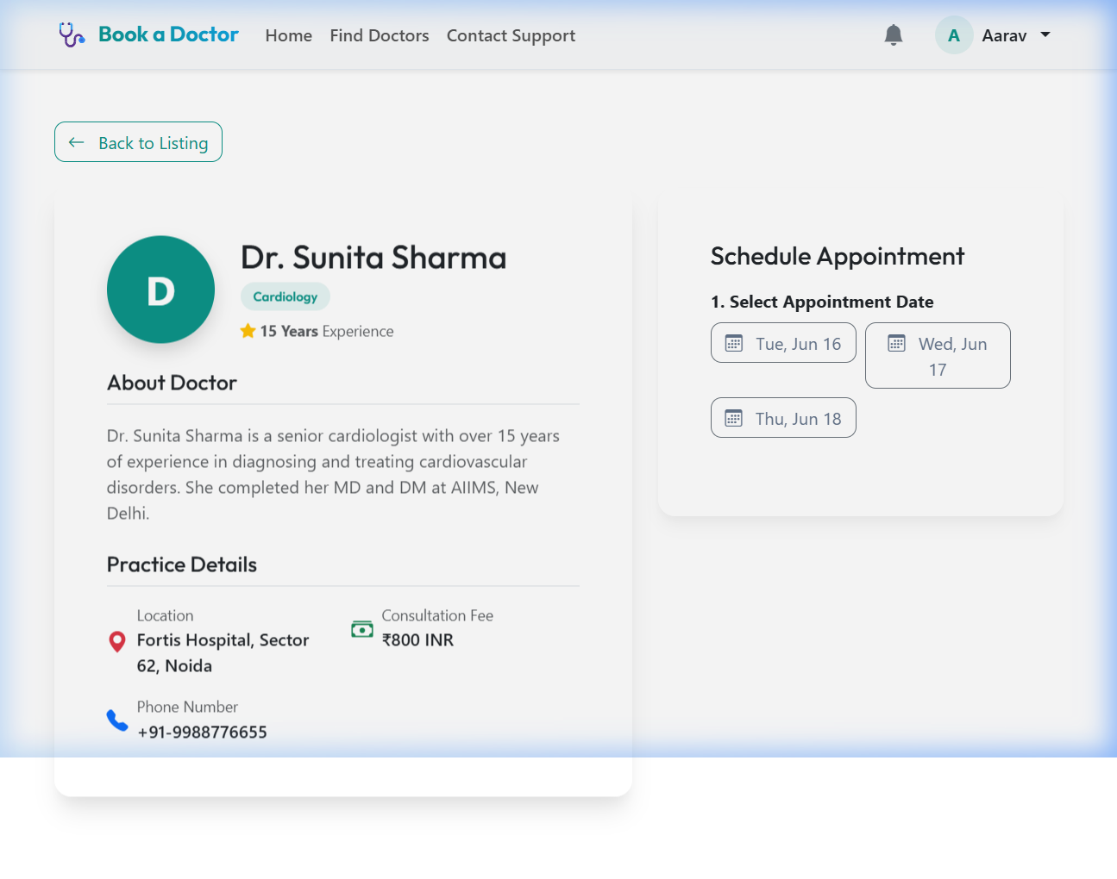
Doctor Profile Screen

Prescriptions & Document Uploads
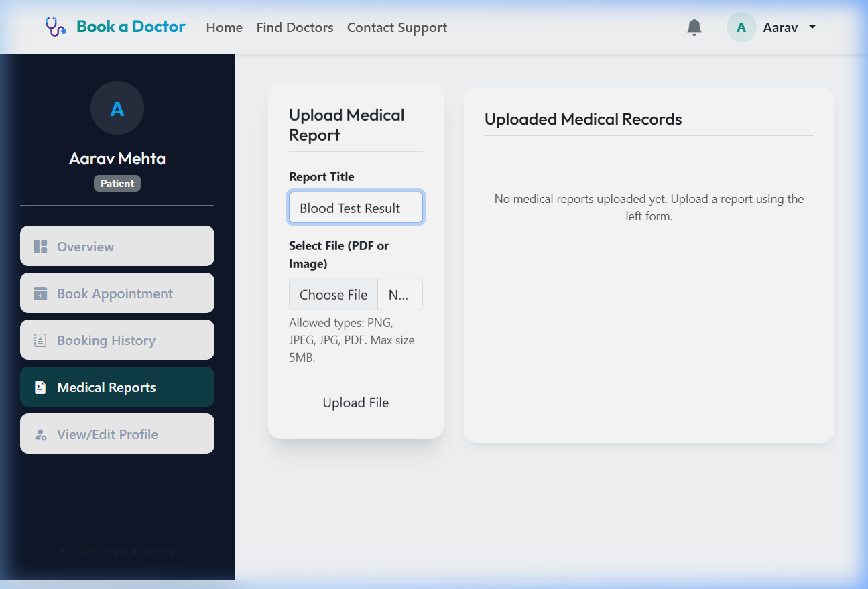
Medical Records Uploads Screen

____________________________________________________

12. Known Issues

- Static File Cleanup: Deleting a document from the MongoDB collection deletes the DB record, but the static binary remains in server/uploads/ directory until clean-up scripts are executed.
- Concurrency Slots: Multiple patients booking the exact same time slot at the identical millisecond can create concurrent requests before mongoose model saves write validations.

____________________________________________________

13. Future Enhancements

- Video Consultations: Integration of WebRTC logic for remote medical checks directly on the platform.
- Automated SMS Alerts: Twilio gateway setup to remind patients of upcoming bookings.
- Payment Integrations: Checkout integration to allow digital payments directly at scheduling checkout.

